We are not Selling Pizza



Why Metrics Matter

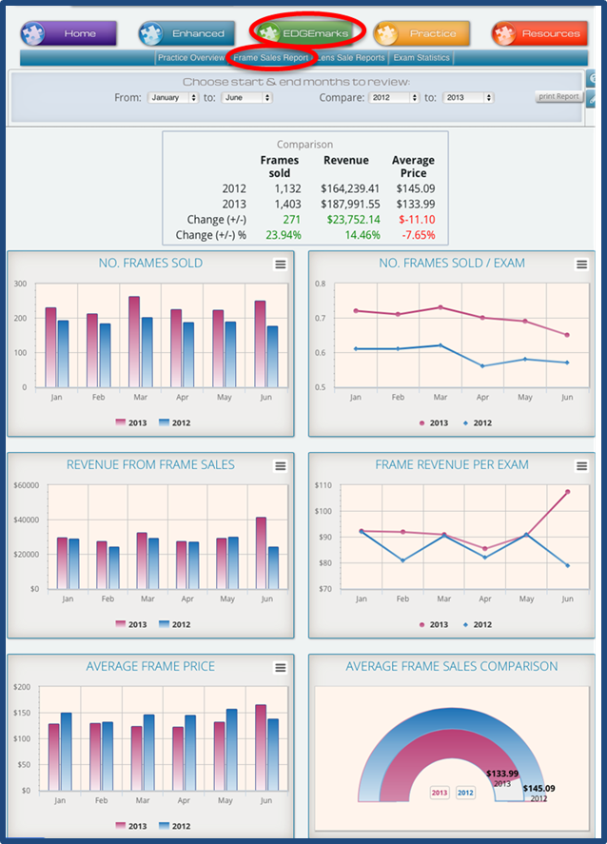

Graphics: © 2015 Gateway Professional Network, LLC. All Rights Reserved

Measure Metrics that Matter

**We Are Not Selling Pizza!**

The owner of a pizza business has one primary focus – selling pizza. The owner of an optometry business must split the focus into two distinct categories – clinical care and retail sales. As such, optometry practices are unique, complex businesses. Tracking data from each revenue stream along with determining the cash flow effect of daily decisions can be daunting.

Important data to consider in running your practice might include the following:

What is your Average Revenue per Exam? How is this revenue divided between clinic fees and product sales? How would knowledge of this help your business decision-making?

What is the exact percentage of lenses dispensed in your practice that include an Anti-Reflective treatment? Transitions? Exactly how many pairs of polarized sun lenses did you dispense last month?

Speaking of lenses, what was your exact revenue generated from selling lenses last year? How does it compare to this year? Did you raise prices? Did you lower them? What effect would raising or lowering lens prices have on your average per-pair revenue?

How about Frames? What is your revenue from Frame Sales? What would be the effect of raising or lowering your frame prices? Besides affecting your bottom line, would implementing one of these strategies affect other areas of your practice such as staff efficiency?

Do you have an overall or “30,000 foot perspective” of where all of your practice revenue comes from? Armed with this information, how might you use it to influence decisions you make to ultimately improve your practice?

All of these questions are answered though studying data and metrics pulled from your practice management software. However, how easy is this for you to do currently?

We will now look at examples of the above using specific metrics you can track that when maximized, can have a big impact on your bottom line. For discussion purposes, the following screenshots were taken using a tool available from a strong vendor partner of IDOC, Gateway Professional Network (GPN™). GPN’s™ The EDGE™ is a web-based business analysis solution that mines data from your practice management system. The data is then displayed in easy to understand reports, charts and graphs. The Edge currently integrates with OfficeMate, RevolutionEHR, Compulink, My Vision Express and Crystal PM, with other PMS integrations in development.

**Average Revenue per Exam: Retail vs. Clinical**

Do you have a report that separates revenue generated in your medical clinic from revenue generated in your optical? The example presented is found in the EDGEMarks Exam Statistics section of ‘The EDGE’. Take a moment to review the charts and data, and then answer the following questions.

1. What stands out to you about this comparison between the first 7 months of 2012 to the same time period in 2013?

2. Do you think the increase in patient exams the sole reason for the increase in revenue?

3. Why is the Average Revenue per Exam an important number to track?

4. What is likely happening when you see that the Average Revenue per Exam comparison is higher in the optical and lower in the clinic than the previous year?

5. What is the value of separating this comparison between clinic and optical differentials?

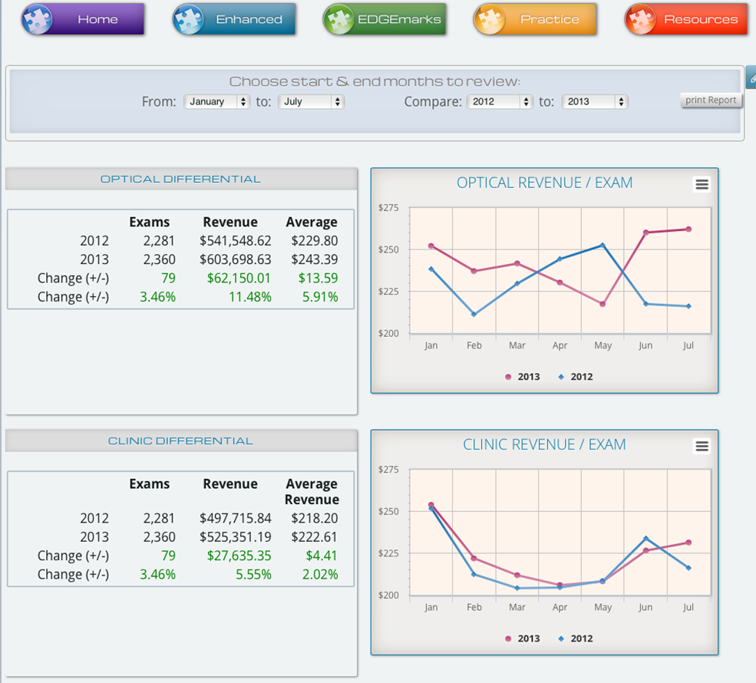

Graphics: © 2015 Gateway Professional Network, LLC. All Rights Reserved

**Lenses and Add-ons Utilized**

Do you know the exact percentage of AR sales in your optical? How about the percentage of AR sold by each doctor? By each optician? By each doctor / optician combination? How would this information be helpful? Presented below is an example of The EDGE Practice Breakout report.

1. What is the number one selling progressive during this 7 month time frame in 2013?

2. How many different types of progressives are being sold?

3. What advantage would be gained by reducing the number of progressive lens types sold?

4. How can this information be used if you are negotiating lab pricing?

5. What is the average progressive lens sale compared to the average “other lens” sale?

6. What opportunities do you see for increased revenue in the Sales Statistics column?

.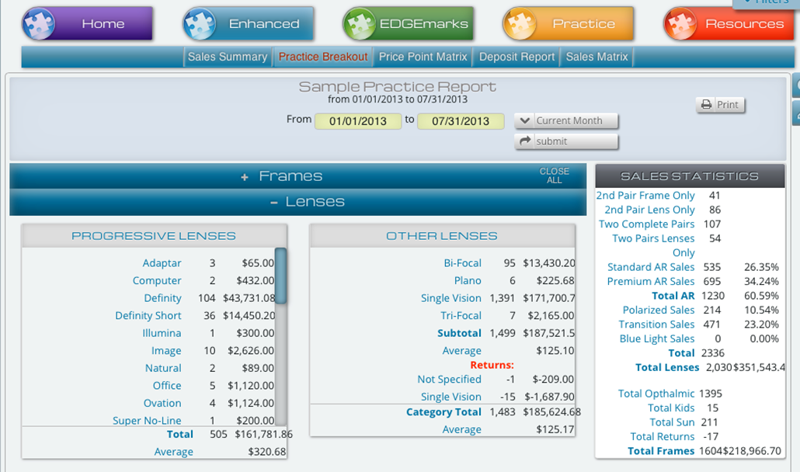

Graphics: © 2015 Gateway Professional Network, LLC. All Rights Reserved

**Lens Sales**

From the data below, we can see that this practice sold more lenses and generated more revenue in 2013 than 2012, but the average lens price dropped.

1. Do you think this was the result of a new strategy employed, or “working harder and not smarter”?

2. Based on this data, what changes would you put in place?

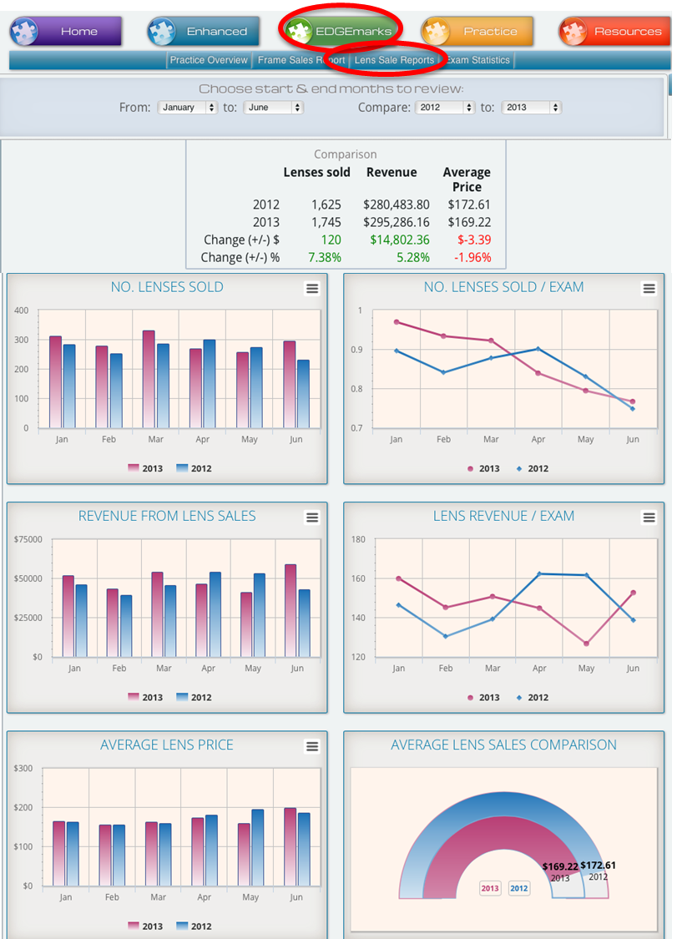

Graphics: © 2015 Gateway Professional Network, LLC. All Rights Reserved

**Frame Sales**

In this example Frame Sales report, the practice sold more frames and generated more revenue in 2013 than 2012, but the average frame price dropped by 7.65%. Let’s imagine that this example shows a tried strategy to lower frame prices to increase sales.

1. What was the difference between the numbers of frames sold in 2013 vs 2012?

2. How much additional revenue was seen in 2013 vs 2012?

3. If the average frame price had stayed the same in 2013 as it was in 2012, how much additional revenue would have been generated by the 271 additional frame sales?

4. Was the tried strategy successful? Why or why not?

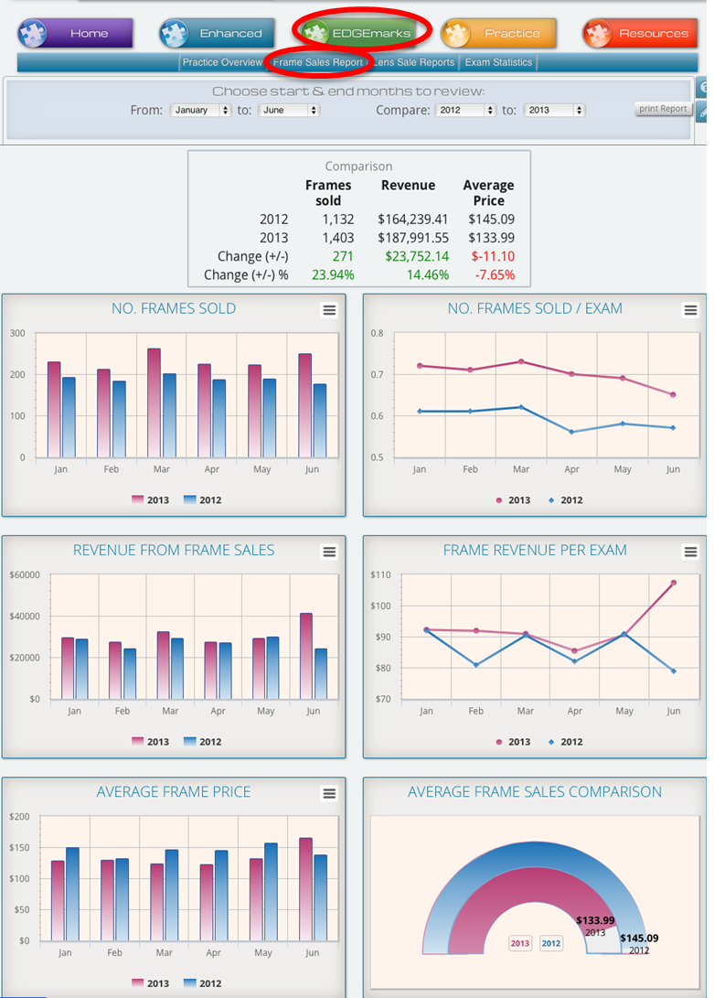

Graphics: © 2015 Gateway Professional Network, LLC. All Rights Reserved

**Sales Summary**

The Sales Summary gives a breakdown of each revenue category in the practice and allows you to compare data from the same time period in the previous year. In this six month period, notice how the practice did more exams, sold more glasses…. almost everything looks green. The one red category is Other Exams. Through further inspection you can find that was caused because the front desk became lax in discussing ancillary testing such as Optomap or MPOD testing. This would have gone unnoticed without easy access to data and metrics.

1. How much revenue did the practice lose during this 6-month time period on Other Exams?

2. Which of the two businesses had the highest increase in total sales revenue, the clinic or the optical?

3. What is the difference in new patient exams? How could this number validate your marketing strategy?

4. How many additional boxes of contact lenses were sold? How is this information beneficial to you when working with a contact lens distributor?

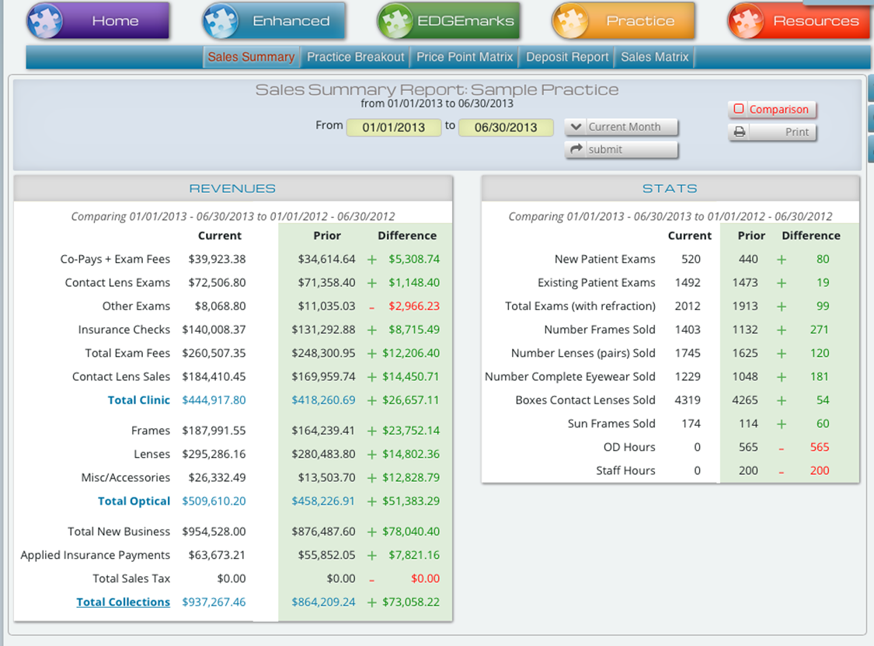

Graphics: © 2015 Gateway Professional Network, LLC. All Rights Reserved

**Summary**

Optometry practices are complex businesses that combine service and retail sales complicated by ever-changing vision and medical insurance payers. Keeping track of both sides of our business and making sure we are profitable can be overwhelming. In addition to what was discussed in the preceding examples, here are a few other everyday business decisions we make as practice owners. The bullet points under each are meant to stimulate thought, discussion.

Decisions facing the optometrist include the following:

1. Introducing a new frame line.

* + Are you replacing an existing frame line or adding additional inventory?
  + Do you need additional frames at this price point?
  + How do the profit margins compare to your current frame lines?
  + What effect does cash tied up in new inventory have on the rest of your practice?
  + What do you expect the turn rate of the new line to be and what do you base this expectation on?
  + What will the average patient out of pocket for the frame be for patients with each vision care plan you accept?

2. Changing the type of progressive lens dispensed.

* + How do the profit margins compare to current lenses dispensed?
  + Is there a retail price difference?
  + What is your current lens capture rate? Will the new lens improve the capture rate?
  + Is there a charge for remakes?
  + For vision plans, how much will patients pay out of pocket for the new progressive lens compared to current progressive lenses dispensed?

3. Deciding to accept a new vision or health plan.

* + How will this affect patient scheduling?
  + Does the plan cover your chair cost per hour?
  + How does it compare to other plans accepted?
  + Does bringing on this new plan allow for dropping another lesser paying plan?

Reviewing data and employing metrics from a program such as the EDGE on a routine basis can help with making the answers to questions like these clearer. This ensures the health of our practices and validates decisions we make. We encourage you to focus on data and metrics from your practice. A core value of IDOC is to provide the resources for independent optometry to thrive. Our partnership with GPN provides the tools for our members to accomplish this objective.

For more information, or to get your EDGE™, contact [info@GatewayPN.com](mailto:info@GatewayPN.com) or call 631-626-9783.